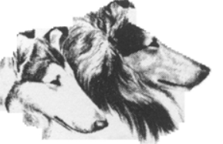

COLLIE CLUB
OF AMERICA
CERTIFICATE OF APPRECIATION
Nomination Form
- Nominee
- Nominee is submitted by:
(Give position, phone number, e-mail address.)

- Please describe why this person should be recognized with this nomination:
- Please include a non-returnable photograph of the nominee.
(Label photograph(s) with nominee’s name. If applicable, include the name and date of the event pictured. Send by email.)

- Send completed nomination form and checklist items to.

Nancy Anstruther – (403) 227-4807 – (Canada)
tallywood@telus.net

CHECKLIST: Only complete nominations will be considered. Please include:

- Photograph of nominated individual. (Send by email)
- Description of the contribution to the Collie Club of America that this individual shared. (250 words or less)
- Application form with nominee’s and submitter’s names and contact information.

